# Food Security Analysis: The Case for AI-Powered Community Assistance

## Executive Summary

The Foodbank Hunger 2024 report found that "nearly seven-in-ten (69%) single parent households have experienced food insecurity" with 41% facing severe conditions (Ipsos Public Affairs, 2024, p. 16). With 53% of Australians households unaware of available food relief services, there's a critical gap between need and access that AI-powered solutions can bridge.

## Key Findings

### 1. Scale of the Problem

* 73% of households experienced food insecurity for the first time in the past 12 months.
* This represents a significant portion of the Australian population requiring immediate support.

### 2. Acute vs. Chronic Food Insecurity:

*1/ First time experiencing food insecurity among food insecure households. Source: Ipsos Public Affairs (2024), Hunger Report 2024, p. 18.*

Most food insecurity is an acute crisis, not a chronic condition:

* 73-77% experienced their first episode within the past year
* 12-16% have been food insecure for 1-2 years (increasing trend)
* 11% represent long-term food insecure households (stable vulnerable population)

**Insight**: The acute nature of food insecurity suggests that timely, responsive interventions through AI agents could prevent short-term crises from becoming long-term problems.

### 3. Awareness Gap

***2****/ Figure 21. Whether Australians know where to get help or support for food relief.* *Source: Ipsos Public Affairs (2024), Hunger Report 2024, p. 34.*

Knowledge of food relief services remains critically low:

* 2022: 38% knew where to access help
* 2024: 47% knew where to access help
* 53% still lack awareness of available services

**Insight:** Despite improvement, more than half of Australians don't know where to find help when needed. This information gap is exactly what an AI agent can address through proactive, accessible communication.

### 4. Service Utilization Crisis

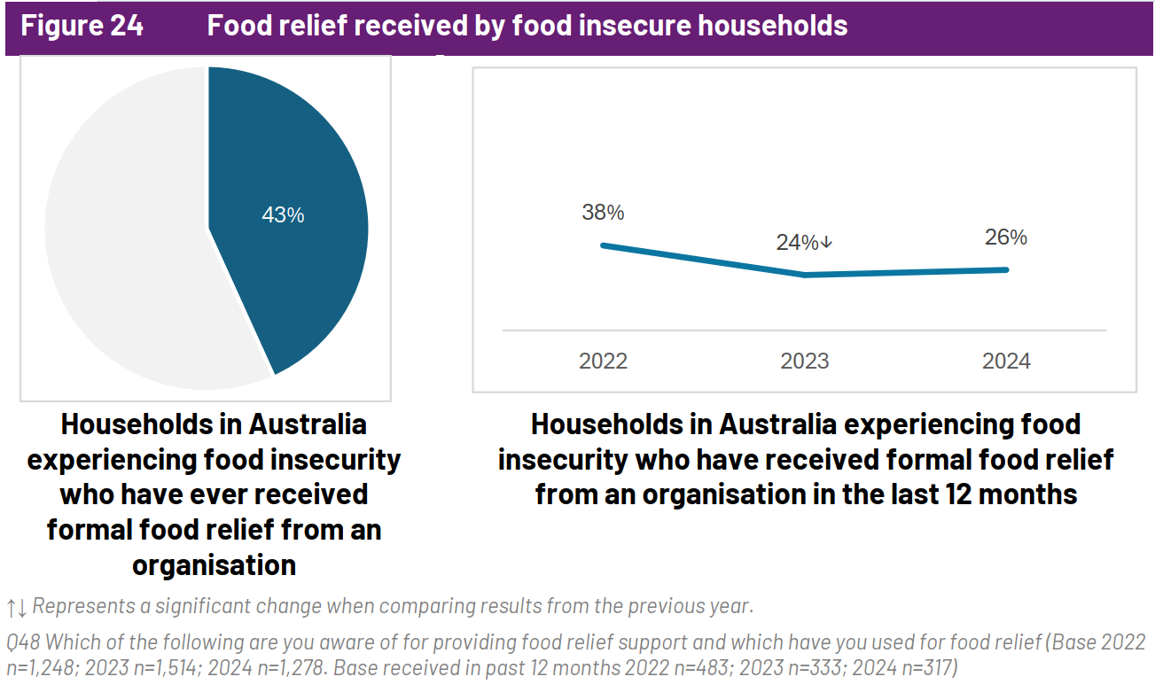

*3/ Figure 24. Food relief received by food insecure households. Source: Ipsos Public Affairs (2024), Hunger Report 2024, p. 37.*

Only 43% of food-insecure households received food relief in 2024:

* 2023: 24% received support
* 2024: 43% received support
* Despite doubling, 57% still receive no help

### 5. Barriers to Access:

*4/ Figure 29. Barriers to accessing food relief among food insecure households 2024. Source: Ipsos Public Affairs (2024), Hunger Report 2024, p. 41.*

Social stigma is the primary barrier (48% of households – NET Food Insecure):

* 48% feel embarrassment/shame
* 52% of severely food insecure households feel ashamed
* 43% of moderately food insecure households feel ashamed

Other significant barriers:

* 36% believe others need it more
* 33% are unsure about eligibility

## The AI Agent Solution

### Problem Statement

Our analysis reveals a disaster of food insecurity:

1. High need (73% of households affected the first time)
2. Low awareness (53% don't know where to get help)
3. Social barriers (48% too embarrassed to seek help)
4. Underutilization (57% of those in need receive no support)

### How AI Agents Address These Gaps

#### 1. Eliminating Information Barriers

* Identification of nearby food relief events
* Multilingual support for diverse communities

#### 2. Reducing Social Stigma

* Anonymous, private interaction through digital channels
* Dignified access without face-to-face embarrassment
* Normalized service discovery through everyday technology

#### 3. Ensuring Eligibility Clarity

* Automated eligibility screening
* Clear, simple explanations of qualification criteria
* Immediate confirmation of entitlement to services

#### 4. Autonomous Task Execution

* Automatic booking of appointments/slots
* Form completion assistance
* Reminder systems to prevent missed opportunities

### Target Impact

#### Immediate Benefits

* Bridge the 53% awareness gap through proactive information delivery
* Reduce stigma barriers for the 48% who feel embarrassed
* Increase utilization beyond the current 43% success rate

#### Long-term Community Impact

* Prevent acute crises from becoming chronic food insecurity
* Build community resilience through better resource allocation
* Create inclusive access for digitally excluded populations

## Scalability & Future Vision

### Beyond Food Relief

Our AI agent architecture scales seamlessly across all community services - healthcare appointments, housing assistance, mental health support. One intelligent assistant, unlimited possibilities.

### Multi-Service Integration:

* Healthcare: GP appointments, specialist referrals, mental health support
* Housing: Emergency accommodation, rental assistance, housing applications
* Education: Adult learning programs, digital literacy courses, language classes

### Adaptive Intelligence

As our AI learns from each community, it becomes smarter. The system continuously evolves through:

### Predictive Analytics:

* Forecasting demand patterns for different services needed
* Identifying at-risk households before they experience crisis
* Optimizing resource allocation based on community needs

### Local Customization:

* Language support tailored to community demographics
* Accessibility features for aging populations

### Continuous Learning:

* User feedback loops to improve service recommendations
* Integration with government databases for service availability
* Machine learning models that adapt to community needs

### Vision & Impact

Imagine every Australian having a personal government services assistant in their pocket - breaking down barriers, eliminating bureaucracy, building connected communities.

**National Transformation:**

* Universal Access: Digital strategies ensure no one is left behind
* Proactive Government: Services reach people before crises occur
* Community Connection: AI facilitates peer support networks and volunteer matching
* Data-Driven Policy: Anonymous analytics inform better service planning

**Measurable Outcomes:**

* Increase service utilization across all community services
* Reduce time-to-access from weeks to hours
* Create cost savings through efficient resource allocation
* Build stronger, more resilient communities

## Conclusion

The data demonstrates a clear market failure in food relief service delivery. While services exist and awareness is slowly improving, significant gaps remain in connecting those in need with available support. An AI-powered community assistant represents a scalable, dignified, and effective solution to bridge these critical gaps.

## Reference:

Affairs, I. P. (2024). *Hunger Report 2024* (24-048445-01). <https://reports.foodbank.org.au/wp-content/uploads/2024/10/2024_Foodbank_Hunger_Report_IPSOS-Report.pdf>